Lock Bound - PIR

Team 177

Dan Ferguson - PM

Joseph Fanning

Azaan Majeed

Euan Tennant

Aden Barr

Adam Wright

Contents:

Contents—-------------------------------------------------------------------------------------------------- 2 Project Summary —-------------------------------------------------------------------------------------- 3

Purpose & Expected Benefits —---------------------------------------------------------------------- 3

Cost & Duration —---------------------------------------------------------------------------------------- 4

Requirements & Quality Expectations —------------------------------------------------------------ 5

Stakeholders Map —------------------------------------------------------------------------------------- 7

Appendix A —----------------------------------------------------------------------------------------------- 8

Appendix B —----------------------------------------------------------------------------------------------- 8

Appendix C -------------------------------------------------------------------------------------------------- 9

**1 - Project Summary:**

**1.1.** This report is being written with the intent to discuss the “Lock Bound - Web-Based Game” project and the reasoning behind the creation of the project. The following sections of this report will detail the creative team behind the project and the needs, requirements and general criteria laid out for developing and finalising a successful project.

**1.2.** The main criterion of the project is to design and implement a web-based puzzle game that will show off the Edward Clark Collection (see Appendix A) which is held within the University. The collection is a deep history of books, typography and printing and binding techniques found throughout 15th Century Europe. As aforementioned, this collection is being held in Edinburgh Napier University, Merchiston campus.

**1.3.** The project will take place over the next few months, resolving it to an early May deadline. This allows our team plenty of time to act on the three main stages of development on the project. It will start with the **design stage**, creating a variety of well-formed wireframes and discussing a selection of ideas for any additions, puzzles, and concepts for the website. The **implementation stage** where we will put these designs and concepts into a functional and working website. Finally, the **refining stage** where we will put the site to the test and polish off any kinks in the site.

**1.4.** During the process of creating this project, we will receive feedback at each stage of development from our client, Iain Donald. Additionally, updates will be made once major tasks are completed within any of these three stages.

**2 - Purpose and Expected Benefits:**

**2.1.** As earlier mentioned, Lock Bound is gonna be a web-game based off of

Edward Clark, a 19th century Edinburgh based publisher and keen collector of rare and antiquated books, scholarly journals, religious scriptures and typefaces. His collection is currently held by Edinburgh Napier University within the Merchiston campus. The awareness of this wonderful collection of media is generally sparse; there isn’t much information online other than the **Edward Clark Collection** website (see Appendix A) which gives a brief account on his life and shows a few items from his collection.

**2.2.** The collection is also held within an air-tight chamber in a secure room within the Merchiston campus, further reducing the awareness and general knowledge about this interesting collection. One of the reasons LockBound was commissioned was to try to raise the awareness and popularity of the collection by creating a web-based game similar in style to that of the fictional wikipedia game; Omnipedia (see Appendix A). Within Lock Bound, users traverse through an informational wikipedia-styled website which contains some biographical information about Edward Clark as well as the various maps and media within his collection, having to complete tricky puzzles and mini-games to progress through to different sections of the website.

**2.3.** The idea of utilising a web-based format to promote the Edward Clark Collection achieves a diverse number of benefits, not only to the collection, but to the beauty of legacy publishing, traditional media and unique typefaces as a whole. The web-based format offers several benefits, including accessibility, engagement, and ease of distribution. A web-based game ensures: Accessibility on multiple devices, no need for installation, easy to update and maintain and being engaging for younger audiences. However, some drawbacks could include browser compatibility issues as well as security considerations for login access.

**2.4.** The game is designed for university-aged young people as well as high school students. This demographic is most likely to appreciate the interactive learning experience and benefit from the educational content.

The use of promoting this collection via a web-based video game will hopefully peak/renew younger generations interested into just how much work went into publishing time-honoured media and creating typefaces for books and scriptures.

**2.5.** Additionally, there are a few different benefits to the team in which this project was commissioned to. This project gives the team a chance to further build on skills related to the development and deployment of web-based applications, further utilising the skills gained from previous years of study.

**3 - Cost and Duration:**

**3.1.** Currently, the group have all been assigned with their own tasks to complete, these include the research and testing of mini games which will be implemented into our game, early wireframe ideas to help the team get an understanding of what the game may look like, and initial drafts of a website to implement designs. The client informed us that there is no cost or deadline for any parts of our outcome except for the module deadline in April/May.

**3.2.** Despite this, we have decided that it is best to get started on each stage very early so that we can really design something we are happy with in the end. We have given ourselves personal deadlines which we will look to complete for us to be able to make any slight adjustments that we are not satisfied with. Doing this has given us the opportunity to be flexible with our time, making it an easier environment to work in.

**3.3.** As mentioned previously, there are three main stages of development for this project. This includes the **Design, Implementation** and **Refinement** stages. As informed by the client, the rough timescales for these stages are as follows:

**Design - Weeks 1 to 4**

**Implementation - Weeks 5 to 10**

**Refinement - Weeks 11 to 14**

**3.4.** The team is working to complete the report before its deadline in February. Once this is complete, we will look to move on to further development of our game until we believe we are finished with it. It is estimated that this will be a reality in mid-to-late March. Once concluded, the focus will turn to the final project report, which will be handed in on or before the 2nd of May. Once this has been settled, we will meet and discuss our presentation which will be on the 9th of May.

**4 - Requirements & Quality Expectations:**

**4.1. Must Have -** The game must have a fully functioning website that is accessible in modern web browsers. It must also have an interface that is similar in design to wiki websites with pages that contain content from the Edward Clark Collection. It must also have a progression system where users unlock new pages by completing minigames and collecting collectables. A prototype hosted locally, as the project does not require full deployment.

**4.2. Should Have -** Due to us already having the code, the game should have an account system which allows users to register an account, log in to their account and save their progress. The game should also have a user interface that is accessible on many different devices such as mobile devices. The game should also have 3 minigames (Connections, crossword & riddles).

**4.3. Could Have-** The game could have a minigame similar to the game Wordle (see Appendix A) where there is a word, and users have a limited amount of guesses to guess the word. It would also show when you got a letter right and the letter is in the correct place or if you got a letter right and it was in the wrong place. The game could also have a word search minigame where there are lots of random letters with words hidden inside that users must find. It could also have a game similar to the game connections (see Appendix A) where there are 4 rows of 4 words and users must find the connections between 4 words.

**4.4. Won’t Have -** The game won’t have a world map that a player character traverses and instead will be in a wiki-based format similar to wikipedia. The game will also not have information on things outside of the Edward Clark Collection.

**4.5. Quality Expectations -** The game should have a visually appealing, intuitive and straightforward user interface that is easy to navigate and easy to understand. The minigames should not have any significant glitches and should function as expected. The game should have accurate information on books from the Edward Clark collection. The game should be regularly tested during development to make sure that it works smoothly and correctly.

**5 - Stakeholders Map**

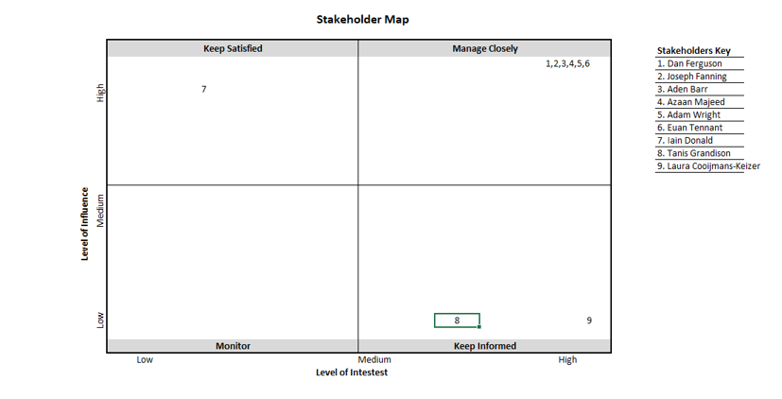

**6 - Appendix A:**

Edward Clark Collection - <https://edwardclarkcollection.com/>

Omnipedia - <https://omnipedia.app/wiki/2049/10/01/Main_Page>

Wordle - <https://www.nytimes.com/games/wordle/index.html>

Connections - <https://www.nytimes.com/games/connections>

**7 - Appendix B - Peer Review:**

PIR Review – Rebecca Allen - [40584778@live.napier.ac.uk](mailto:40584778@live.napier.ac.uk)

Lock Bound Project - Group 177

* The personal deadlines show good internal management and will be helpful for organisation in the project.
* It would be good to narrow down the target audience a bit further - will these games/puzzles be achievable for school age children, or more targeting undergrads?
* In section 2.3, it is mentioned that web based format has many benefits. What are these benefits? It could be good to break this section up a bit with a small table showing pros and cons to having the game online.
* Have you discussed with the client how/where the website will be hosted? Or even if it needs to be hosted to be completed as a project, perhaps this is just a proof of concept. As our project also requires a website, we have considered asking to use the university server.

**8 - Appendix C - Client Confirmation:**